Tianle Yuan
CS 550
October 1, 2020
Project 1

Name: Tianle Yuan
Email: yuant@oregonstate.edu
Project Number: 1
Project Name: Draw Something Cool in 3D!
Web Link: https://media.oregonstate.edu/media/t/1_1jk9xguj
Screen Captures：
In this project I have drawn a famous graphics operator named LoG. The first picture is the shape with projection.
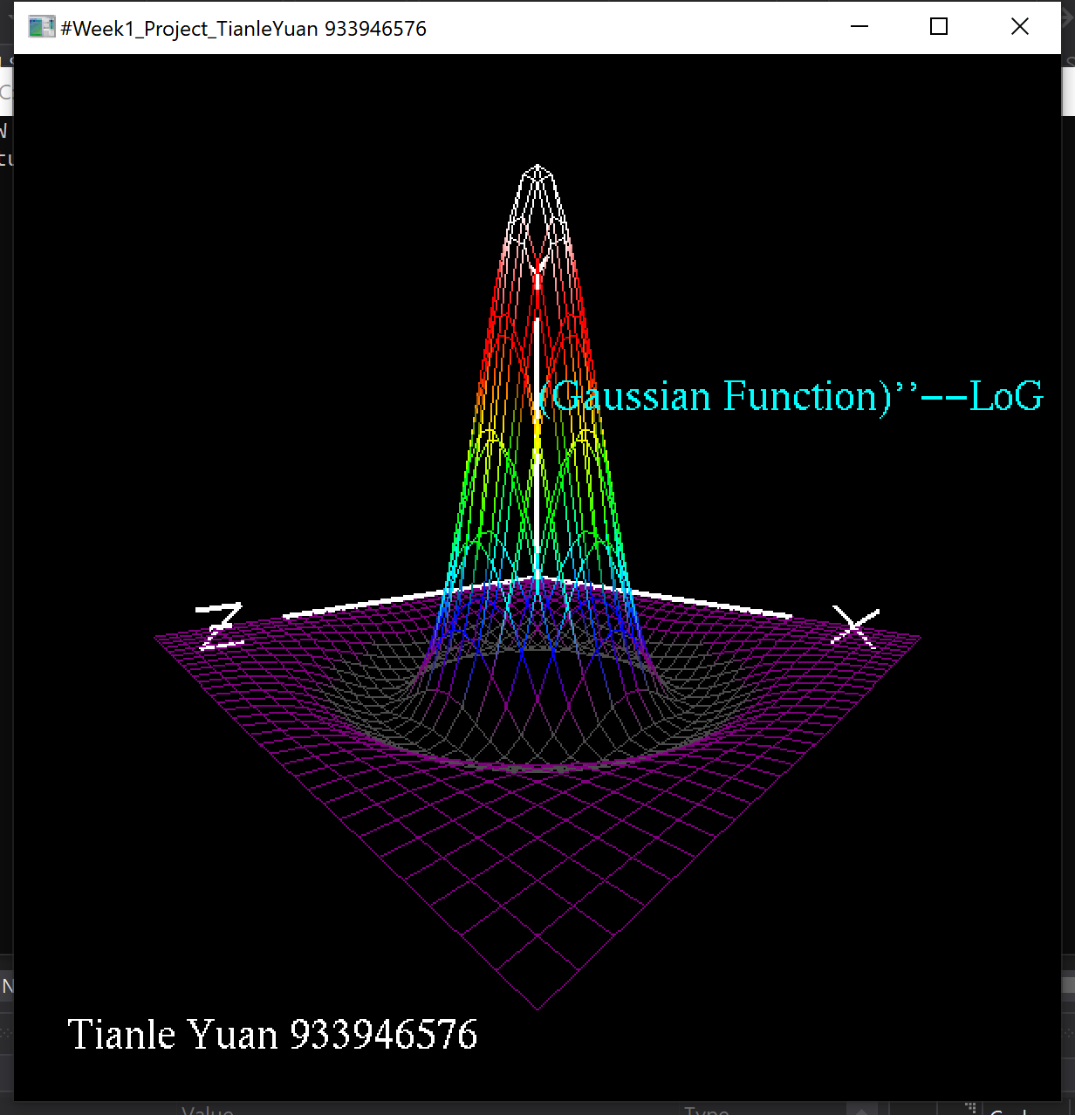
The second picture shows that I have used 32*32 x-y-z points for drawing my own shape.
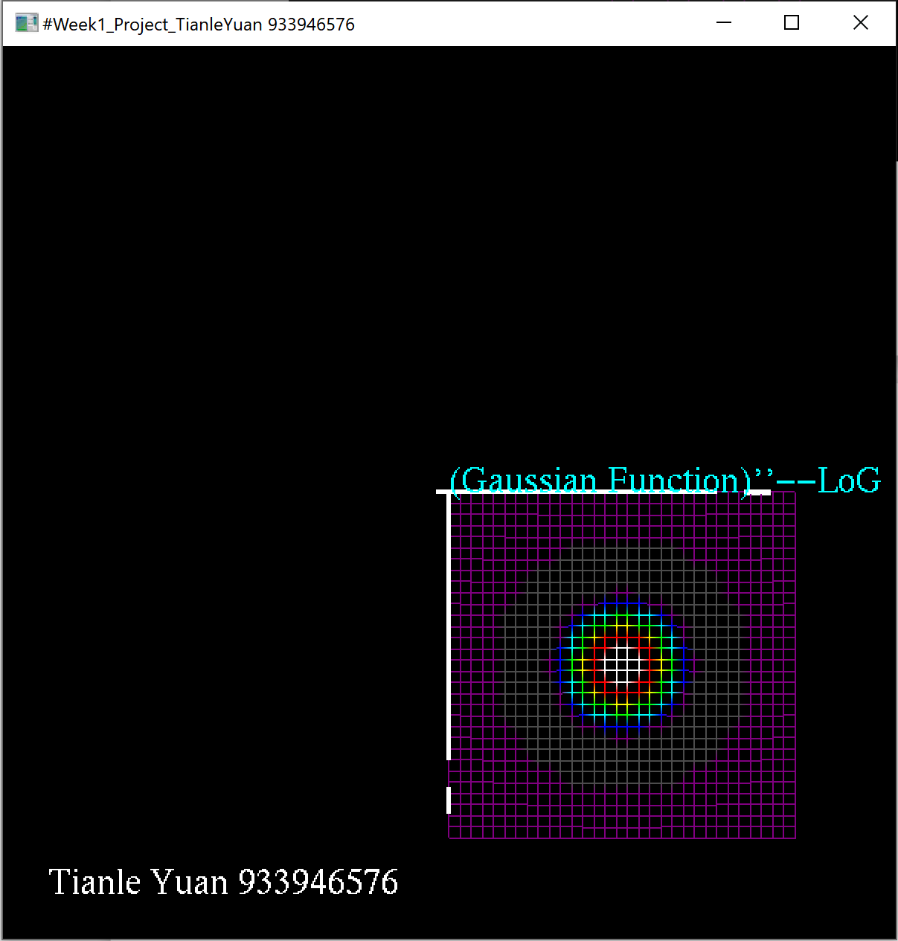
The third picture shows that there are 8 colors I have used for my shape when we see it horizontally. They are purple, gray,blue,cyan,green,yellow,red,white.
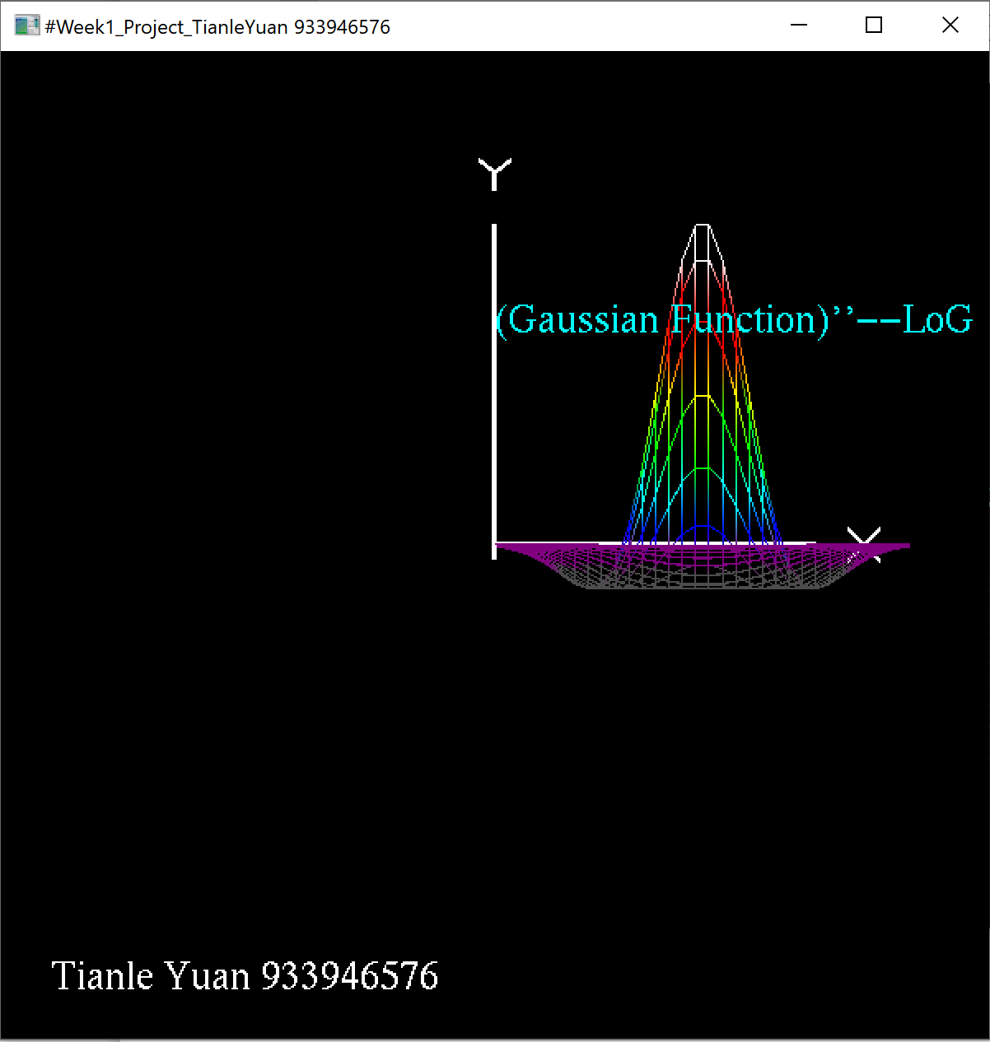
Scaling and Rotating:
